[](https://www.findagrave.com/memorial/143872645/terrance-lee-evans) [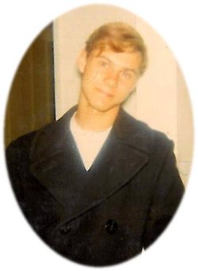](https://www.findagrave.com/memorial/143872645/terrance-lee-evans)

# Terrance Lee “Terry” Evans

Birth: 18 Jan 1953

Kansas, USA

Death: 12 Nov 1971 (aged 18)

Walnut, Los Angeles County, California, USA

Burial: [Queen of Heaven Cemetery](https://www.findagrave.com/cemetery/8293/queen-of-heaven-cemetery)

Rowland Heights, Los Angeles County, California, USA

Plot: Sec. D; G-19; Tear 60

Memorial ID: 143872645

Terry was a senior at Walnut High School in Walnut, California, and working as a service attendant at gas station operated by the Atlantic Richfield Corporation, also in Walnut, California. Terry had been working at the station for only 4 days when he and fellow employee Karl Baranowski Jr. were killed in the store room of the station during a robbery. A total of $49 was discovered missing from the cash box.